AVATAR: Problem List User Guide

Adding/Editing Items on the Problem List
- Select a client by either:
  - Clicking on the client name in your “My Clients” list
  - Searching by last name or client number in the “Search Clients” field
- In the “Search Forms” field, type “Problem List” and double-click on the selected form to open it
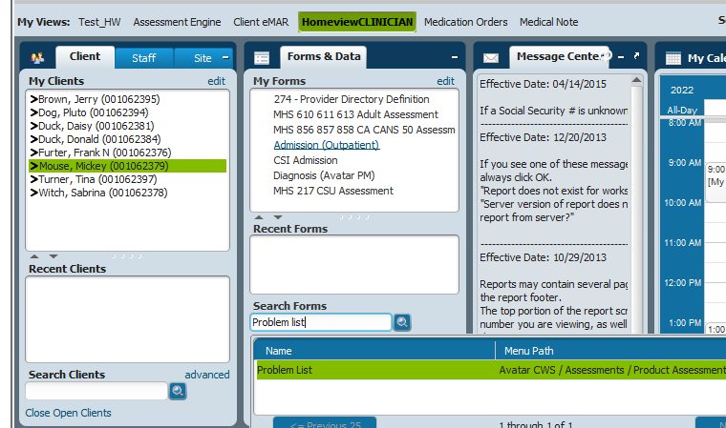

- The Problem List launch form will open
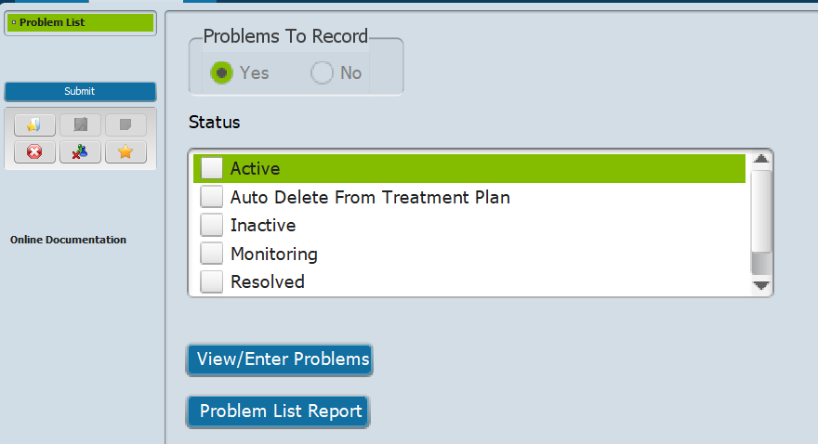
- Click on “View/Enter Problems”
- The Problem List entry form will open

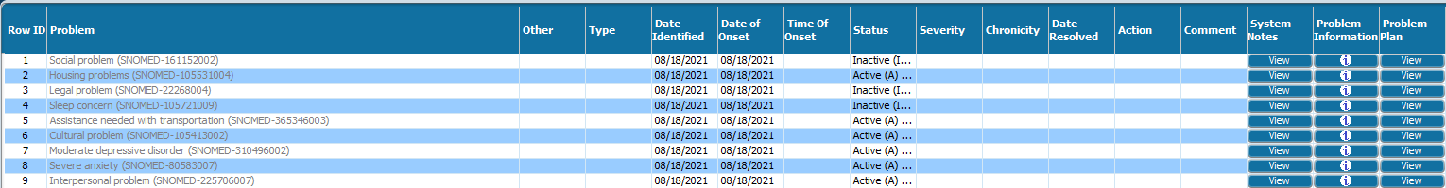

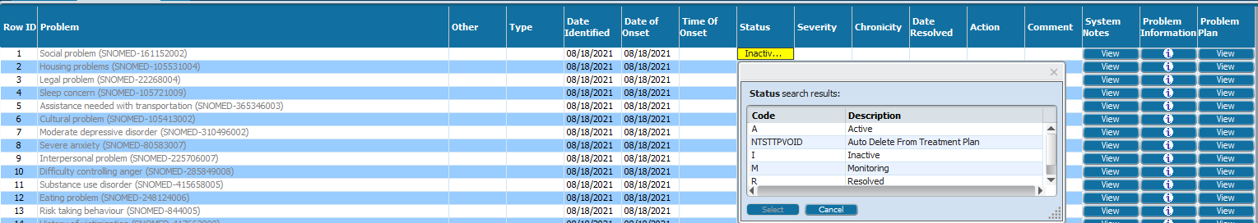
- To change the status of a problem, double click on the Status and select from the drop-down list.

- To add a new problem to the list, click on “New Row” at the bottom of the screen and fill in the row.
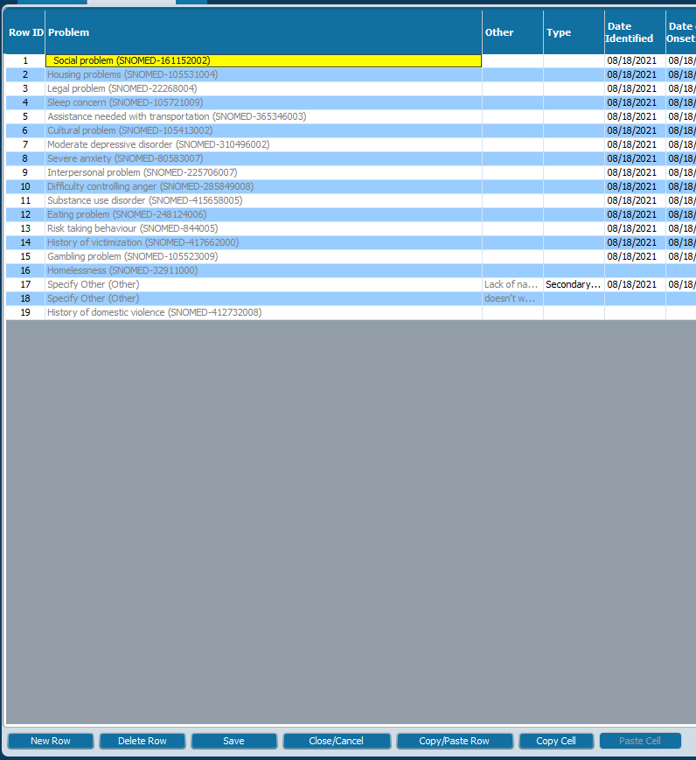
- Click “Save”

- You will be returned to the Problem List launch form
- Click “Submit”

Printing the Problem List
- Select a client by either:
  - Clicking on the client name in your “My Clients” list
  - Searching by last name or client number in the “Search Clients” field
- In the “Search Forms” field, type “Problem List” and double-click on the selected form to open it

- The Problem List launch form will open
- Select the Problem Status categories to print (e.g., “Active”)
- Click “Problem List Report”
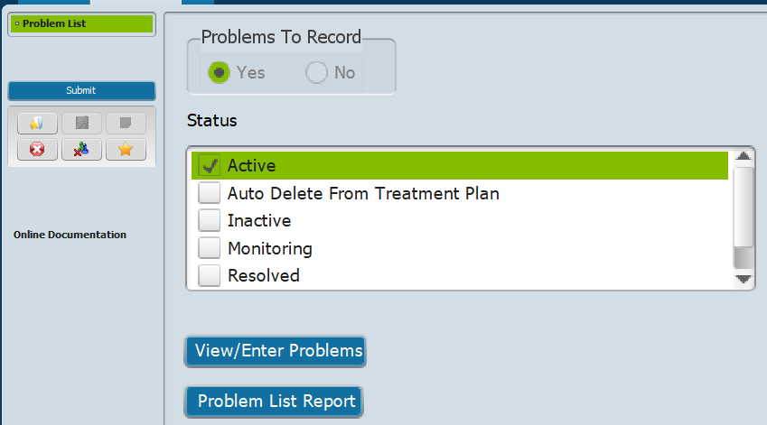
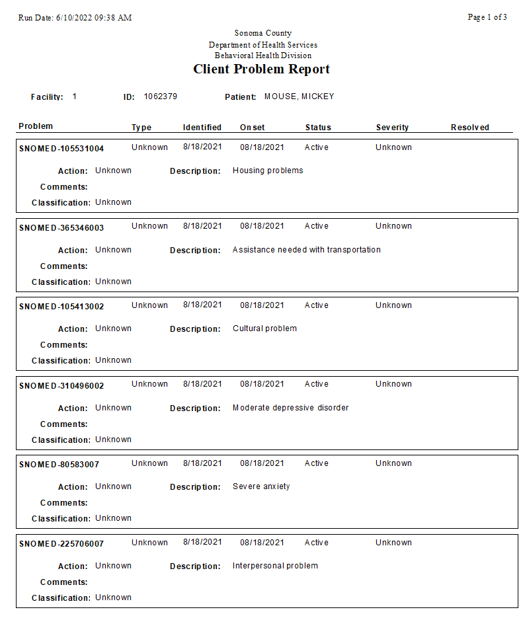
- A report will generate listing the problems in the selected status
- To export the report, click on the export icon at the top left of the page and save the report as a PDF or Word document
- To print the report, click on the printer icon at the top left of the page.
